Sparsh Agarwal  Address for Correspondence:  University of Petroleum and Energy Studies  Energy Acres PO Bidholi via Prem Nagar  Dehradun-248007 (Uttarakhand), India  Mobile: 8126586222  E-mail-agarwalsparsh15@stu.upes.ac.in | 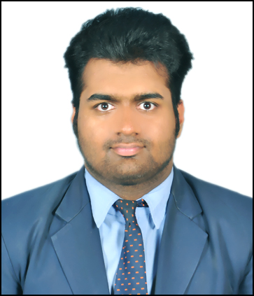

CAREER OBJECTIVE

Industry oriented aim of Work, Learn, Achieve and Repeat carrying the mindset to invent and innovate the possible solutions of a task and explore new ideas by facing the challenges.

ACADEMIC BACKGROUND

 |  | Qualification – Degree |  |  | College |  | Percentage /
 | Year(s) |  | Board/University |  |  |  | CGPA
 |  | / Diploma / Certificate |  |  | / Institute/ University
2015-19 |  | B.Tech Computer Science Engineering in Business Analytics and Optimization | University of Petroleum and Energy Studies |  | College of Engineering Studies |  | 7.52
2015 |  | XIIth | CBSE |  | Vision Valley School |  | 75.6
2013 |  | Xth | CBSE |  | Vision Valley School |  | 9.20
 | INTERNSHIPS
Institution: |  | Kyrion Technologies Pvt. Ltd.(Noida) |  |  | Duration: 2 Months
Project Title: |  | Data Analysis on Pokemon Characters
Mentor: |  | Ms. Kapila Jain
Description:

A data analysis on pokemon characters to study the properties according to the various dimensional aspects for a particular set of conditions & constraints in Hive using HDFS on the Virtual Server Machine.

Institution: Wonderpillars Technologies Pvt. Ltd(New Delhi) Duration: 1 Month
Project Title: Website Dvelopment(Commercial)
Mentor: Mr. Akhtar Hussain
Description:
A dynamic and fully integrated live project is created for a commercial website using HTML5, Advanced PHP and WordPress. The website loads with dynamic approach rather than the standard static code at the front-end.
TRAININGS & PROJECT UNDERTAKEN

MINOR Projects

Project Title: Stock Holding System Using Prediction Modeling

Mentor: Mr. Jatin Sethi

Description:

A C++ designed tool to manage the stock holding of the user by creating a database record of the stock which would help to analyze the present situations of the stock and helps in to study which item would be beneficial for holding it in the future by analyzing the trends of a item for a particular time interval.

Project Title: Nutrition Chart Generator

Mentor: Dr. Piyush Chauhan

Description:

A tool was created in the C language to generate the diet chart of the different people diet's habit by in taking their rough features. Based upon this the tool produced the result according to their status and providing recommendations of diet using the preloaded dataset and by optimized clustering of food items.

Other Projects Institution:
Project Title:
Mentor:

Description:

ClickDoor Private Limited(Dehradun) Duration: 3 Months

Prototype building for a budding startup
Mr.Punit Singh

A part time contribution in the development of prototype and database handling for the budding startup to enhance the learning as well as gaining the prospects required for a particular job.

Institution: UPES Duration: 6 Months
Project Title: Predictive Analysis for Stock Exchange Model(PASE)
Mentor: Mr.Saurabh Shanu

Description:

The tool will primarily assist on what basis a bank or an investor should invest in a particular company. The tool needs rating on a scale of 5 according to which the analysts will give reviews about that particular company they are planning to invest on.

ACADEMIC / EXTRA CURRICULAR ACHIEVEMENTS

  - Big Data & Python Certified by HP Enterprise INDIA & LearnCodeOnline.in respectively.

- University Certified in PHP & MySQL.

- Certified for Augmented Reality in 3-Days Training by Intel Corporation.

4) City Rank 1: National Cyber Olympiad (2014).

5) Lead Singer (representing School) at singing Event held at IIM Kashipur.

6) Class Representative of the branch from the year 2016-Current.

COMPUTER SKILLS

Softwares : Microsoft Office,XAMPP,Eclipse,Jupyter,DB2,Hadoop,SQLServer.

Languages : C,C++,Java,Python,Scala(basic),HTML5,PHP,Hive,Bootstrap,Wordpress,MySQL
Operating Systems : Windows XP and above, Linux (Ubuntu).

PERSONAL DETAILS

Date of Birth | : | 07-02-1998
Father’s Name | : | Mr. Ashutosh Agarwal
Mother’s Name | : | Ms. Deepali Agarwal
Category | : | General
Gender | : | Male
Nationality | : | Indian
Home Town | : | Kashipur
Permanent Address | : | 71/57 ,Basant Vihar,Girital Road,Kashipur,Uttarakhand
Phone No. | : | 9837173469
Languages Known | : | Hindi,English
Mobility | : | Anywhere around the globe

I declare that the details above are correct and true to the best of my knowledge.

Sparsh Agarwal

