- CURRICULUM VITAE

Abhijeet Shukla

ABHIJEET SHUKLA

B.E.
Vedica Institute of Technology,
Bhopal (M.P.) India

Cell Phone Number
+91 9235382100

E-mail
almighty.abhijeetshukla@gmail.com
abhijeetshukla780@gmail.com

Father’s Name
Mr. Sudhakar Prasad Shukla

Mother’s Name
Mrs. Indu Shukla

Permanent Address
B1-177 New Ashok nagar New Delhi

Personal Data
Date of Birth:27th June 1994
Nationality: Indian

Hobbies
- Friendship with unknown person

- Bike & Car racing & modify

Languages known
- English
- Hindi

Career Objective
To gain an insight view in a challenging environment, this provides me the opportunity to exercise my engineering and interpersonal skills which can help me to enhance my knowledge for the development of self and organization

Branch of Study
- Mechanical Engineering

Academic Qualification

Qualification | Year of Passing | Institute | Board/University | Percentage
B.E. | 2017 | Vedica Institute of Technology,  Bhopal | RKDF University Bhopal(M.P.) | 76.3
Senior Secondary | 2012 | RAM  School | U.P | 69.8
Higher Secondary | 2009 | BBS intermediate School | U.P | 59.4

Computer Skills

Operating System |  | : | Windows 7/8/10
Language Known  Database |  | : | PHP  Mysqli
Frame Work |  | : | CodeIgniter Laravel
Scripting Language |  | : | HTML CSS Bootstrap
Software |  | : | MS Office Internet
Achievements

- Got 1st rank in junior scientist competition in saving of electric power and electric lose in area and archive gold medal in School level, Distr. Level, state level in 2008
- Got 1st rank in Senior scientist competition in Information technology IT Field to cover Indian LOC and archive gold medal in School level, Distr. Level, state level in 2009

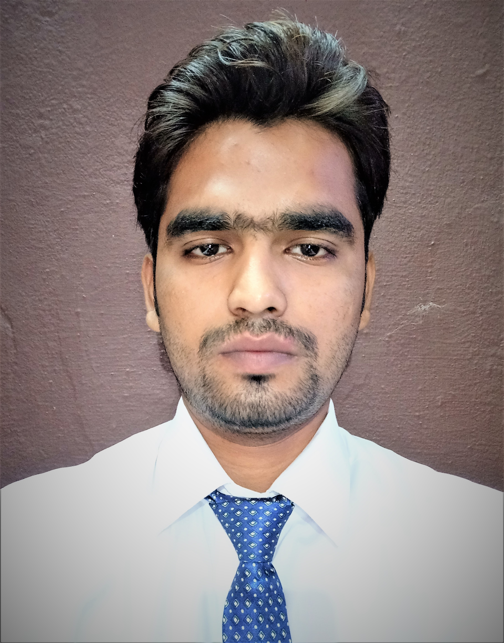

Image

Key Skills Proficiency
- Good communication skill
- Command on latest computer software like MS Office and designing software mechanical and civil both
- Can work effectively in team, as well as individually
- Knowledge in codeigniter framework soap api and project testing
Experience

- Now working at: Codifier technologies pvt. Ltd (joining date 29-04-2018 to tell…)
Project

Complete one school management dummy full project in a time of internship using codeigniter framework
Complete one live project worldedge using codeigniter framework (team size 2)
url(https://www.worldedgetravels.com/)
Complete one live project myskillspay online url (https://myskillspay.com) (team size: 1 only me)
Complete full testing on travel-tech project
Now working on government project sevak app and youMe using codeigniter framework (team size: 1 only me)

Extra Curricular Activities

- Member of organizing committee of college fest 2k15
- Making a new design of one multi used laptop in this laptop sometime two person complete our work easily and one new design of finger used wireless mouse, potable keyboard also

- Design of one special laptop which is used in any type of car its design in fully based according the car design

- Making one type of special function which automatic control of our LOC

Declaration
I hereby declare that the above information is correct to the best of my knowledge and belief.

Date : ..............................
Place : .............................. (Abhijeet Shukla)

