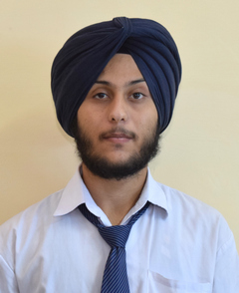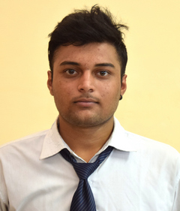

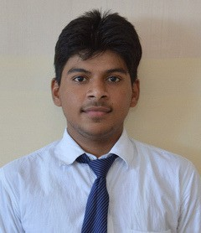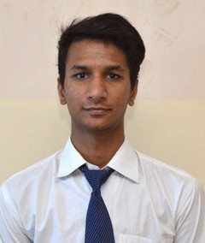

AMANDEEP SINGH SETHI

Te c h n ic a l S kills

DBMS

C

HTML, CSS, SQL

R

P e rs o n a l S kills

Good Communication Attentive Team Player

Optimistic

Versatile

Ho b b ie s

Cricket

Dance

Playing arcade games

+91 9759944510

LD-49 SEC-F lda colony kanpur road, Lucknow

Pincode-226012

Amandeep.sethi_cs15@gla.ac.in

P e rs o n a l D e ta i l s

S U MMAR Y

Enthusiastic Computer Science Engineer with hands-on C, DBMS,R with friendly, helpful and team player skills seeking a position in an organization that utilizes my skills.

E D U C ATIO N

Bachelor in Technology(Computer Science) 6.16 Current, CPI 2015-2019

Intermediate:59.6 % 2014-2015

P R O J E C TS U N D E R TAKE N

High School: 56.7% 2012-2013

PROJECT TITLE: Titanic disaster analysis

Technology used:Using R with machine learning

PROJECT TITLE: Technologe

Technology Used: HTML and CSS

CO- CURRICULAR ACTIVITIES & WORKS HOPS

Attended a workshop on Cloud computing at IIT-DELHI.

Attended workshop at IEEE for R analytics.

Scored first position in Counter Strike even held at GLA University

Coordinated the lohri event in 2017.

Member of ABACUS Society.

S U MME R TR AIN IN G

Summer Training in Android from MSCC computer centre, Lucknow

D E C LAR ATIO N

Declared that the information provided is true and best to my knowledge and belief. Nothing has

been concealed within

DATE: SIGNATURE: