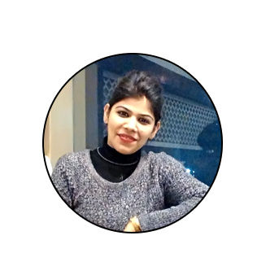

**HELLO**

I'm **Amarpreet Kaur**

**SR ENGINEER (GRAPHIC DESIGN)**

**AGE ADDRESSE-MAIL PHONE**

28

256, Krishna Colony, Gurgaon-122012 SONIA.SEHMI90@GMAIL.COM

9910501044

Hello! I’m Amarpreet Kaur. Senior Engineer specializing in Graphic Design. I am a consistent person with good ability to learn concepts quickly. I have the capability of working under significant pressure and possess a strong ability to perform effectively, also possess the ability to develop and maintain mutually beneficial relationships with the colleagues and as well the clients. I assume that I can work as an individual and in a team. Possess a good command over English which gives me the confidence to put across my ideas and concepts easily.

**Professional Skills**

Photoshop 100% Illustrator 90%

Flash 85%

# **Work Experience**

### 2011 -2016

INFOTEL TECHNOLIGIES PRIVATE LIMITED

ENGINEER

* Designing layouts in **Photoshop.**
* Designing logos in **Photoshop.**
* Creating **Website Layouts**
* **Graphics Design** by using Adobe Illustrator.
* Creating Interactive Business Presentations by using Adobe Photoshop and PowerPoint.

**2016 -Present**

INFOTEL TECHNOLIGIES PRIVATE LIMITED

SR. ENGINEER

* Designing layouts in **Photoshop.**
* Designing Mobile App UI using **Photoshop and Illustrator.**
* Designing E-Learning content by using Photoshop, illustrator, Flash**.**
* Designing **2D Animation** videos using **Flash, Voice Editing.**
* Designing logos in **Photoshop**
* **Graphics Design** by using Adobe Illustrator.
* Creating Interactive Business Presentations by using Adobe Photoshop and PowerPoint.
* Having the knowledge to work over **Data Cards and Mobile.**

# **Education**

**2008 -2011**

## Bachelor of Computer Application

Guru Nanak Dev University, Amritsar.

**2008**

## 10+2

Punjab School Education Board, Amritsar.

**2016-2018**

## Master of Computer

## Application

Lovely Professional University, Jalandhar

**KEY TECHNICAL SKILLS**

|  |
| --- |
| **Software’s Undertaken and proficient in** |
| Photoshop 7, CS5,CS6, CC |
| Adobe Illustrator CC |
| Flash Animation |

**SPECIALIZATION COURSE**

* Adobe Photoshop
* Sig Sigma Belt Certification

**ACHIEVEMENT**

* Won Gold Medal In Judo At School Level.

**DECLARATION**

I hereby declare that all the above statements are true and correct to the best of my knowledge and belief.

Place:-**Gurgaon**