CONGRATULATIONS TO BBDNITM NPTEL TOPPERS
Course Run | Topper
Jul - Oct 2018-19 | 1  Ms. NEELESH CHANDRA VAISH  Topper of 1% in this course  Computer Science Engineering  (Elite + Gold)  COURSE NAME: Problem Solving through Programming in C
Jan-Apr 2018 | 1  SHUBHAM AGRAHARI  TOP 5 % OF CERTIFIED CANDIDATES  COURSE NAME: PRODUCT DESIGN AND MANUFACTURING
Jul-Dec 2017 | 3  ANMOL MAHENDRA  TOP 5 % OF CERTIFIED CANDIDATES  COURSE NAME: PROGRAMMING, DATA STRUCTURES  AND ALGORITHMS USING PYTHON

ARPIT MISHRA
TOP 5 % OF CERTIFIED CANDIDATES
COURSE NAME: INTRODUCTION TO INTERNET OF THINGS
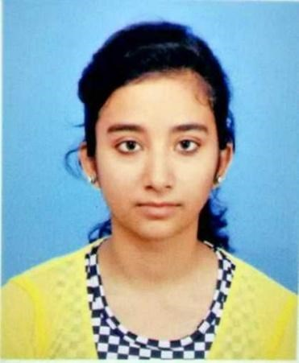
PRIYA SRIVASTAVA
TOP 5 % OF CERTIFIED CANDIDATES
COURSE NAME: INTRODUCTION TO PROGRAMMING IN C

Jan-June 2017 | 3  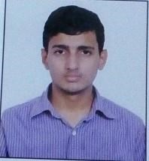  YOUSUF KAMAL  TOP 1 % OF CERTIFIED CANDIDATES  COURSE NAME: INTRODUCTION TO MODERN APPLICATION DEVELOPMENT  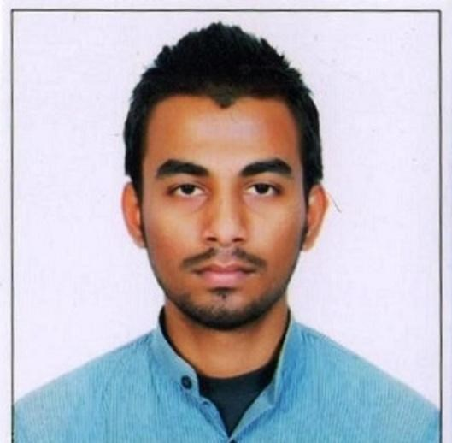  FAIZ AHMED  TOP 5 % OF CERTIFIED CANDIDATES  COURSE NAME: PROGRAMMING IN C++
SHASHANK
TOP 5 % OF CERTIFIED CANDIDATES
COURSE NAME: ENHANCING SOFT SKILLS AND PERSONALITY

