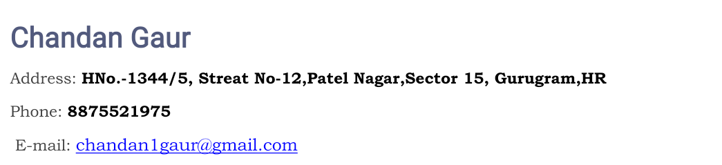

|  |
| --- |
| ***Career Objective*** |

* Seeking a good and prestigious platform to share and disseminate my knowledge and skills.

|  |
| --- |
| ***Work Status*** |

* Looking for a new challenging Opportunities.

|  |
| --- |
| ***Educational Qualification*** |

|  |  |  |  |  |
| --- | --- | --- | --- | --- |
| **Standard** | **School/College** | **University/**  **Board** | **Year**  **Of passing** | **Score**  **(%)** |
| Post-Graduation(MCA) | Maharishi Arvind Institute of Science & Management, Jaipur | RTU | 2018 | 74% |
| Graduation(BCA) | Rajasthan Swayat Shasan Mahavidhyalaya, Jaipur | UOR | 2015 | 65.02% |
| 12th | S.S. Jain Subodh Sr. Sec. School Jaipur | RBSE | 2012 | 60.2% |
| 10th | S.S. Jain Subodh Sr. Sec. School Jaipur | RBSE | 2009 | 56.5% |

|  |
| --- |
| ***Work experience*** |

Currently I am working at Aglasem Edutech as Software Engineer Trainee from Apr 2019.

|  |
| --- |
| ***Technical Skills*** |

* PHP
* Laravel
* MySql
* MongoDB
* JavaScript
* Ajax
* JQuery
* React-native

|  |
| --- |
| ***Personal Information*** |

* **Name** : Chandan Gaur
* **Father’s Name** : Mr. Ramavtar Sharma
* **Date of birth** :10/06/1995
* **Languages Known** : English and Hindi
* **Strengths** : Hard worker, Helpful, Adaptable,Creative Person.
* **Hobbies**  : Playing Cricket, Listening Music, Watching Movies,

Recite Joke.

* **Marital Status** :Single

|  |
| --- |
| ***Declaration*** |

I hereby confirm that the information furnished above is correct to the best of my knowledge.

**Date:**

**Place:** **[Chandan Gaur]**