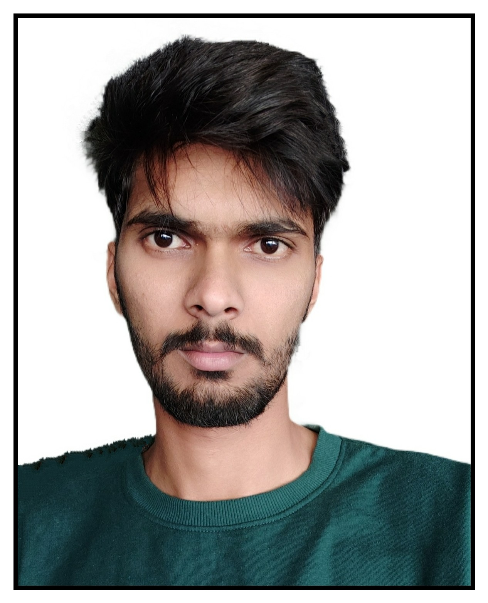**SHASHI PRAKASH YADAV**

**Contact No:** 8299612730.

**E-mail :** shashiit3013@gmail.com.

**Address :** U Block Phase III, Gurgaon, Haryana.

**CAREER OBJECTIVE:**

I have an optimistic outlook towards life to pursue a challenging career and to utilize my valuable skills in the better platform.

Determined to learn with practical approach being Creative, Innovative, Productive and Effective in professional environment. Self-motivated achiever with an ability to plan and execute.

**Academic :**

|  |  |  |  |  |
| --- | --- | --- | --- | --- |
| **Qualification** | **Institute** | **Board/University** | **Year of Passing** | **CGPA/Percentage** |
| B. Tech (IT) | United Institute of Technology | AKTU | 2019 | 69.8% |
| Intermediate | Aditya Birla Public School | CBSE | 2015 | 69.3% |
| High School | Aditya Birla Public School | CBSE | 2013 | 8.8 CGPA |

**Final Year Project**

**Project : Online Web Chat Application**

**Duration :** 6 Jan 2018 – 31 mar 2019

**Technology :** HTML, CSS, MySQL 2012, PHP

**Team :** Atul Vishwakarma, Uttera Kumar Mishra

**Description : Online Web Chat Application is** a website which provides platform for web communication between

people. The frontend of the website was developed in HTML & CSS while the database was maintained in MySQL Server using PHP.

**Summer Training**

**Project : Generation of Delivery Challan**

**Duration :** 13 June 2018 – 12 July 2018

**Technology :** HTML, CSS, MySQL 2012, .Net

**Description :** This website deals with the generation of online Challan for the goods that are received and sent by Hindalco, RPD. The frontend was developed using the .Net framework while database was maintained using MySQL.

**Area of Interest:**

* Database Management System (DBMS)
* Software Engineering

**Technical Skills:**

* C Language.
* PHP and .Net Framework.
* My SQL Server and Database.

**Extracurricular Activities:**

* Coordinator in college workshop and fests.
* Attended two-day workshop on “INTERNET of THINGS (IoT)” in 2018.
* Participated in CodeVita Challenge organized by TCS.

**Interest & Hobbies:**

• Keen interest towards technology.

* Photography.
* Occasional writing.
* Willingness to learn new things.
* Intense interest in cricket.

**Strenghts:**

* Quick Learner
* Leadership skills
* Self-motivated
* Keen observer

**Personal Details**

**• Father’s Name:** Mr. Chandra Shekhar Ram

**• Mother’s Name:** Mrs. Prodheri Devi

**• Date of Birth:** 8 September 1995

**• Languages:** English & Hindi

**• Address:** U Block Phase III, Gurgaon, Haryana

Date - Place -