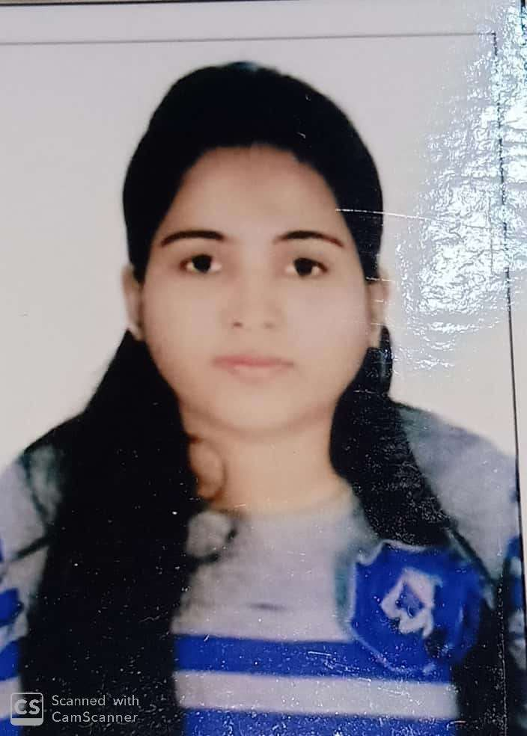
Diksha Jain
B-959, Trans Yamuna Colony, Agra -282006
+91- 8077773791
dikshajain0510@gmail.com
WORK EXPERIENCE
- Currently working with Isha Exclusives and Consulting as HR. Recruiter (Freelancer) from June , 2019.
- Worked at Isha Exclusives and Consulting as an HR. Recruiter .
- Manage Full life cycle of the Recruitment Process (End to End Recruitment) starting from Job Analysis, mapping, sourcing, screening, evaluation, scheduling interviews, follow-ups, offers.
- Hiring for positions at all levels.
- Understanding & analyzing the requirement of the position based on Business Unit specification.
- Seeking Clarity (if required) from the concerned HR / Client lead.
- Head Hunting from LinkedIn, Social Media Hiring, Sourcing of relevant candidates through job portals, Mass mailing from portals, networking, references.
- Assessing the candidates Suitability, Attitude, Academics and Professional qualification, Experience, Communication skills etc.
- Maintain and update status of all ongoing position (status of interviews, candidate short listed for various rounds, pipeline etc).

- Worked as an Associate Training Coordinator at NIIT Ltd , Gurugram.
- Updating the Records of Trainings of the Employees.
- Handling ILT and VILT sessions as Host.
- Assisting the queries of the employees on Call and Mails , providing solutions to them.
- Coordinating with the vendors and session owners for the Training sessions held.
- Maintaining the records and updating reporting authority.
- Coordinating with the internal employees for the different aspects of sessions.
INTERNSHIP
Summer Internship at The Tajview-IHCL SELEQTIONS, Agra (Formerly Known as The Gateway Hotel) in Human Resource Department.
- Maintaining all Records & Files.
- Preparing HR related letters – (Joining , Notice, Experience, Internship)
- Handled Induction and Training Program for New Joiners.
- Looked after Recruitment cycle.
- Handled Employee General Queries and concerns.
- Look after employee welfare activities.
- Handled the attendance & leave management systems to ensure accurate payroll inputs.
- Prepared summer internship project report.

Research Project Report
Conducted an survey on” Performance Appraisal of Employees in Hotel Industry” and prepared an research report.
QUALIFICATION
PROFESSIONAL QUALICATION
Qualification | Year of Passing | University | Performance
MBA – Human Resource Management & Marketing Management | 2018 | Dr. APJ Abdul Kalam Technical University | 68.8%

ACADEMIC QUALIFICATION
Examination | Year of Passing | School/College | Board/University | Performance
B.Sc | 2016 | Narayani Devi Mahavidhyalaya, Hathras | Dr. Bhimrao Ambedkar university | 64.8%
AISSCE(XII) | 2013 | Ess Ess Convent Sr. Sec School, Agra | CBSE | 69.2%
AISSE (X) | 2011 | St . Francis Convent School, Agra |  | 77.9%

COMPUTER SKILLS
Having knowledge of MS Office.
EXTRA-CURRICULAR ACTIVITIES
Dancing and listening Music
Teaching
BIOGRAPHICAL DATA
DOB: October 5, 1995
Language Known : English and Hindi

