# CURICULLUM VITAE

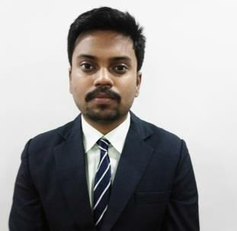**SAPTARSHI CHAKRABORTY**

**E-mail**: [saptarshi.chakraborty0394@gmail.com](mailto:saptarshi.chakraborty0394@gmail.com)

**Con**t**a**c**t** No.:+91 9832469814

**Permanent & Present Address**: 130,Surya Sen Street, Siliguri- 734 006

## CAREER OBJE CTIVE

To work and learn under a good organization which provides me scope to learn more and aspire me to utilize my knowledge for the uplift of the organization.

## ACADEMIC QUALIFICATION

|  |  |  |  |  |
| --- | --- | --- | --- | --- |
| Year Of Passing | Examination | Institute | Board/University | Percentage/Grade |
| 2019 | MBA (HR and Marketing) | Siliguri Institute of Technology | MAKAUT | 7.94 DGPA |
| 2016 | BBA(H) | Siliguri Institute of Technology | MAKAUT | 6.72 DGPA |
| 2012 | XII | Don Bosco School, Siliguri | ISC | 62% |
| 2010 | X | Don Bosco School, Siliguri | I.C.S.E | 61% |

**SUMMER INTERNSHIP PROJECT**

PROJECT WORK UNERGONE : Service quality of the organized retail store with special reference to Pantaloons .

Two months of training at Aditya Birla Fashion Retail at Pantaloons based upon the specialization of marketing from June to August 2018.

Responsibilities of project were: Customer Handling and dealing, Management of the Store, Learning their visual merchandising procedure.

## EXPERIENCE

## Currently working as an Assistant Area HR Manager at

## Reliance Jio Infocomm Ltd. Since 25th Feb 2019.

## PERSONAL DETAILS

Date of Birth : 8th Nov,1993

Father’s Name : Mr. Jayanta Chakraborty Gender : Male

Nationality : Indian Marital Status : Single

Languages Known : English , Bengali , Hindi

Extra Curricular Activities : Watching Movies, Social Networking, Listening Music, Biking, Video Gaming

**DECLARATION**

I Saptarshi Chakraborty, hereby declare that all the information mentioned above are true and correct to the best of my knowledge.

Place : Siliguri

Date: 24th October,2019

SAPTARSHI CHAKRABORTY