**SUGANDH SUSMITA**

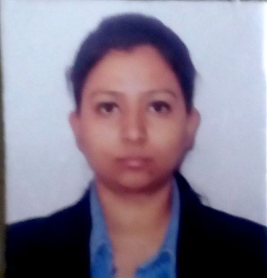Photo

E-mail: Sugandhsusmita@gmail.com

Phone: (+91)7042076351

Certification ID: 0018690158

**CAREER OBJECTIVE**

To associate with a progressive organization which will help in adopting new ideas and concept and developed my aptitude to cattle the organization’s objective and my carrier as well?

**Personal Summary**

* As an HR Executive Currently working with Ronyd Healthcare Pvt Ltd. In Gurgaon.
* Working on boarding, Employee Relations

**Career History Since 1st February 2018**

Position - HR Executive

Company Name– Ronyd Healthcare Pvt Ltd.

Location – Gurgaon

Duties:

* Take care of complete employee Lifecycle from boarding to exit.
* Running on-boarding and induction programs, ensuring integration of new joiners.
* Ensuring fun at work and team building activities are a consistent part of the culture.

**PROFESSIONAL SYNOPSIS**

* Certified SAP ERP 6.0 HCM Consultant from ATOS – SAP Authorized Training Center, Pune

**ACADEMIC CREDENTIALS**

**2015 - 2017 PGDM – Human Resources and Marketing**

Institute of Management Studies, Ghaziabad

Affiliated to AICTE

**2011 - 2014 B.B.A - Finance**

Sinhgad College of commerce, arts and science, Pune

Affiliated to Pune University, Pune

**2009 – 2011 12th – Commerce**

Patna Central School, Patna

Affiliated to CBSE

**2009 - 10TH**

Krishna Niketan, Patna

Affiliated to CBSE

**SUMMER INTERNSHIP TRAINING**

Organization : Furushima India Inspection Centre Private Limited

Duration : 8 Weeks (May-June, 2016)

Profile : HR Intern

Key Learning :

* To understand how to evaluate the performance of the employee in the organization
* To understand how implement the appraisal to the employee in the organization.

**INDUSTRIAL VISIT**

Industrial Visit

* Organization: Yakult Danone, Sonepat

Key Takeaway: Knowledge about production process of probiotic drinks.

* Organization: Parle- G

Key Takeaway: To know about industrial environment and its operation.

* Organization : Indian Agro

Key Takeaway: To know about industrial environment and its operation

**SAP CERTIFICATION**

**SAP ERP HUMAN CAPITAL MANAGEMENT, Version ERP 6.0, EHP 7**

**ATOS– SAP Authorized Training Center**, **Pune**

(13th November 2017 – 8th December 2017)

**IT SKILLS**

* SAP ERP – Human capital management, Version ERP 6.0, EHP 7

**PERSONAL INFORMATION**

Date of Birth : 14th February 1993

Marital Status : Single

Language : Hindi, English

Father’s Name : Mr. Devendra Kumar Sinha

Mother’s Name: Mrs. Neelam Sinha

Local Address : Vijay Vihar, sector 30, Gurgaon, Haryana

I hereby declare that all the above information given by me is true of my best knowledge.

Date:

Place: (**Sugandh Susmita**)