NIGAR MOSARRAT

 | Phone: 9113315552  E-mail: nigar.mosarrat@gmail.com  Date of birth-23/2/1988  Marital status- Married  Language known—Hindi, English, Urdu, Bengali.  Hobbies-literature, painting, trekking. | 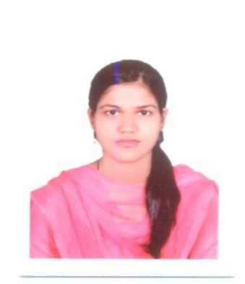

Objectives
To obtain a challenging position in a progressing organization that fosters growth, and will allow me to utilize my interpersonal and academic skills to pursue a challenging and rewarding career.
Professional Experience
- RECRUITMENT EXECUTIVE in CARTE BLANCH for 6 months from oct'16-April'17.( Recruiting for Genpact,Genpact Head strong,Tech-Mahindra,Sopra-Steria)
- Working as Faculty of BBA Dept. in PURNEA WOMEN’S COLLEGE and teaching experience of 2 years.(2013-15)

- Summer Internship in LINK LOCKS PVT. LTD. Aligarh,( 3 months)

Educational Qualification

MBA(HR) from Aligarh Muslim University, Aligarh.(2013)

Level | Stream | Institute & Board | MARKS
10th | ……… | C.B.S.E.DELHI | 70 %
12th | Humanities | C.B.S.E,DELHI | 84.4
Graduation | BA- ENG(Hons) | BNMU, Bihar | 63 %

COMPUTER EDUCATION

Advance Diploma in Computer Applications (ADCA)
- SPSS software used for research work.

RESPONSIBILITY
- Organized college student trips to Dargeeling,siliguri.

House captain in 10 th - K.V CRPF, Durgapur (W.B)

Team leader of Darjeeling Trekking team(2004)

Organized and anchored programs during graduation in women’s college, purnea.
ACHIEVEMENTS
- CBSE- 2nd Topper -12 th in Kolkata region.
- Bronze medal for international Essay competition - Avantika.
- ‘A’ in trekking, by Neora Valley Adventure Course, Darjeeling.
- Workshop on Entrepreneurship development program in NSIC.
- First in speech contest at women’s college purnea .
- Many prizes in yoga, Olympiads and model teacher program.
- Article in Dainik jagran on “I will vote to”.

STRENGTH
- Self confidence.
- Positive attitude.
- Co-operative
- Workaholic
PERSONAL details
Residential Address :
D-6,phase -4, opposite water tank, ICICI ATM, Ayanagar Extension, New Delhi-110047.

DECLARATION
- I hereby declare that the information given above is true and best of my knowledge and belief.

( Nigar mosarrat)

