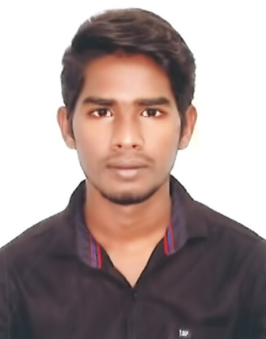  M.JEGAN RAJ m.b.a.(HR),  OBJECTIVE  To work and get trained in a challenging and dynamic environment and to keep adding value to the organization that I represent and serve, and to myself, while upgrading my skills and knowledge.  Skills  - Communication  - Team Work  - Training and Development  - Good Decision  - Flexibility  - Adaptability  - Positive Attitude towards work.  - Typewriting  FIELD OF INTEREST  - Welfare  - Recruitment  PERSONAL DETAILS  •Date of birth : 15-10-1996  •Father’s name:  Mr. J.Micheal Raj  •Mother’s name  : Mrs. M.Jenitha Mary  •Linguistic ability : Tamil, English (Read and write)  co-curricular  activities  - Took part in NATION SERVICE SCHEME.  - Took part in Donate Blood Camp | 23, Gandhiji Colony, Near Ellis Nagar,  Madurai-625016.  +91 9080689982  +91 9788750606  Jagajj141523@gmail.com  Jegan Raj  Education  B.Sc. (Electronics & communication)• 2017 • Mannar Thirumalai Naicker College (Affiliated to Madurai kamaraj University)  52% Second Class  M.b.a., (Hr) • 2019 • madurai kamaraj university  78%  EXTRA QUALIFICATION  - MS Office  - Certificate programme in Apollo Hospital Management  - Basic Computer, Internet Knowledge  ACHIEVEMENTS  - HR Training at Apollo Hospital  - Hatsun Agro Products Ltd HR Training  - Had undergone training at  - Internship training at Apollo Hospital for 30 days and Hatsun Pvt Ltd.,  PROJECTS  UG PROJECT TITLE :Analysis of Employees Welfare in Apollo Hospital  .  FIELD :Human Resource Management  PG PROJECT TITLE : A study on satisfaction level of Employees towards facilities provide by HAP Ltd  FIELD :Human Resource Management  vivA TITLE  - Employee towards Welfare Facilities  seminars  - Employees Welfare, Satisfaction of Employees, Fenner Industry, SEBI, Employees Training and Development, Procedure of Recruitment, Level of Employee toward Welfare Facitilities.  workshop attended  - Aavin Milk Industry
DECLARATION

I Hereby declare that all the details furnished above are true to the best of my knowledge and belief. I bear the responsibility for the correctness of the above mentioned particulars.
Date: Your’s Truly
Place:

( JEGAN RAJ .M )

