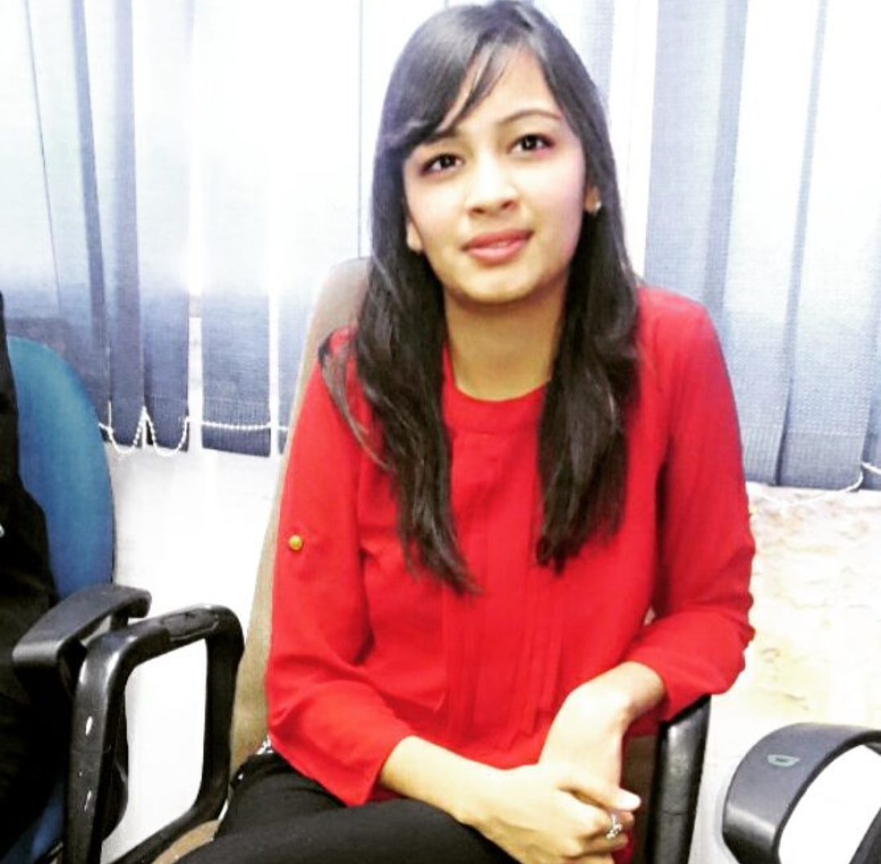

Mahek Bindal

E-mail: mahekbindal029@gmail.com

Mobile: +919911436396

Date of Birth: 20 ^{th} December 1997

Present Address: B-57 Mahavir Enclave Part 1 New Delhi-110045

Language Known: English & Hindi

Hometown: Baraut (UP)

Career Objective

To perform credibly by demonstrating the necessary skills and attitude to successfully operate in the fast paced, performance driven environment and to work with an organization which provides me with challenging opportunity, offers learning, growth, values, creativity and dedication

Work Experience

Current Organization: Iris Computers Ltd
Duration: 1 August 2017 to Till Date
Designation: HR Executive

Roles and Responsibilities:
- Reviewing resumes and applications
- Working with recruitment agencies to source for candidates for specific job positions
- Managing workplace safety issues
- Administration of all contract labor
- Handling the full and final settlement of the employees
- Handling insurance-related issues
- Recording, maintaining and monitoring attendance to ensure employee punctuality
- Preparing letters such as offer and confirmation
- Keeping records of staff insurance and ensuring timely renewal
- Conducting first round of telephonic interview for the candidates to schedule interviews.
- Coordinating with consultants and candidates for scheduling appointments with the management team for sourcing

Previous Organization: Soft bank Energy
Duration: Nov 2016 to July 2017
Designation: Front Office Executive

Roles and Responsibilities:
- Taking care of reception Desk.
- I greet the visitors at the office registering their names and contact details.
- Doing arrangements for Seminars, Conference & Meetings.
- I was responsible for keeping all the Stationery & First aid Items

Educational Qualification

Post Graduation:

Degree: Pursuing Master of Business Management (MBA)
University: Narsee Monjee University

Graduation;

Degree: B.com (Hons.)
University: University of Delhi

Computer Knowledge
- Knowledge of Microsoft Office (Word, Notepad, Excel & PowerPoint).

Certificates

- One year Office Management from YMCA
- 3 Months Basic Knowledge Of Computer

Hobbies & Special Interest

- Dancing and Listening Music.

I hereby affirm that the information in this document is true, complete and correct to the best of my knowledge and belief.

Place:
Date: Mahek Bindal

