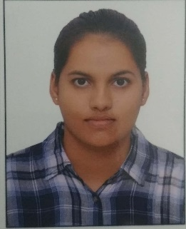
CURRICULUM VITAE

SHALINI RAI
7042023758, 9810471545
House no. 261, First floor, Housing board colony, Sector-40, Gurgaon.
9-Oct-1996.
shalinirai1996@gmail.com

CAREER OBJECTIVE
Ambitious to build a career with an organization where team work is required and hard work is appreciated and to be in a position best suited to my knowledge and skills ,and getting opportunities to grow along with organization.
KEY SKILLS
- Good communication and leadership skills.
- Internet and commerce management
- Time management skills.
- Quick decision making.
- Good working knowledge of internet.
- Computer literate
- MS OFFICE knowledge (word, excel, Power- point, etc.)

Language skills
Language | Read | Write | speak | Proficiency
English | Yes | Yes | Yes | Proficient
Hindi | Yes | Yes | Yes | proficient

Academic Qualifications
Qualification | Year | Institution | Specialization | Percentage
MBA | 2017-19 | MDU (UILMS) | Dual; HR  MARKETING | 84%
B.com | 2013-16 | Govt girls college | Commerce | 70%
Secondary | 2012-13 | CBSE | Commerce | 82%
Elementary | 2010-11 | CBSE | Commerce | 78%

EXPERIENCE
I had worked with TATA CONSULTANCY SERVICES for about six months in this time period I worked in two projects one is SHORE MORTGAGE (USA) and other one is ABN AMRO (NETHERLAND).
Responsibilities:
- Worked as finance associate for six months.
- Handling of verification documents of US residents.
- Dealing with clients and satisfying the necessities required by the ABN AMRO bank.
- Handling the accounts of the Customers and giving the porper Feedback possible.
SUMMER INTERNSHIP
Got an opportunity to work with HR department of Delhi, land and fiancé private limited (DLF) as an intern.
Responsibilities:
- Recruitment of Professionals from Job portals like Naukri, Shine, Monster, Linkedln etc.
- Onboarding of the employees starting from Induction, orientation to the verification of documents.
- Assisting the seniors in day to day work.
- Grievances handling of employees with best efficiency possible.
- Exit interview process.
HOBBIES
- SPORTS:
  - Athletics: Races, Shot-put throw, Javelin throw.
  - Badminton and Football
- Travelling, Drama, knowing about different culture and languages.
ACHIVEMENTS
- Sports captain
- Interschool badminton champion
- Participation in mathematics Olympiad
- Participation in state level kho- kho championship.
- Participation in Annual college fest.

